SIMATS ENGINEERING
ASSESSMENT TOOL 2
COURSE CODE: CSA04 COURSE NAME: Operating Systems

COURSE OUTCOME COVERED
CO1: Apply the concepts of Operating System types, structures, and system calls to demonstrate their functions in various computing environments. (BL2, BL3)
QUESTIONS: 5 Total Marks:100

Annexure A Concept Mapping
Code of Conduct:I Ch.Akhil(192525250) certify that this submission is my original work and that I have adhered to the guidelines specified for this assessment. I understand that any violation of academic integrity rules will result in disciplinary action
Signature of the student: 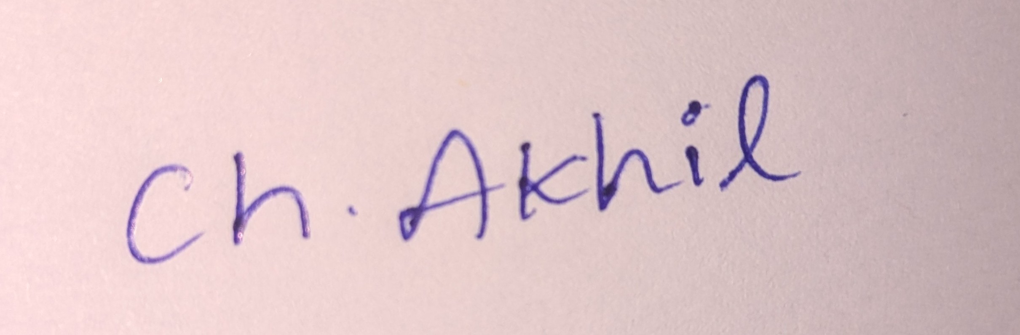

Annexure A
Concept Mapping

Question 1
Show a multi-level concept map integrating:
Operating System Types → OS Structures → System Calls → OS Functions.
Your map must show cross-links (e.g., how OS structure influences system call
implementation). (BL2)

Question 2
Construct a comprehensive concept map representing:
Process Management, Memory Management, File System, and I/O System.
Include interdependencies and indicate where system calls interact with each
component. (BL3)

Question 3
Sketch a comparative concept map for:
Batch OS, Time-Sharing OS, Distributed OS, and Real-Time OS.
Highlight differences, similarities, advantages, and limitations using linking phrases.
(BL2)

Question 4
Illustrate a dynamic concept map showing the execution flow:
User Program → API → System Call Interface → Kernel → Hardware → Response back to User.
Include feedback loops and control flow paths. (BL3)

Question 5
Sketch a hierarchical + functional concept map for system calls:
Process, File, Device, and Information system calls.
Also show how they relate to OS services like scheduling, memory allocation, and device handling.

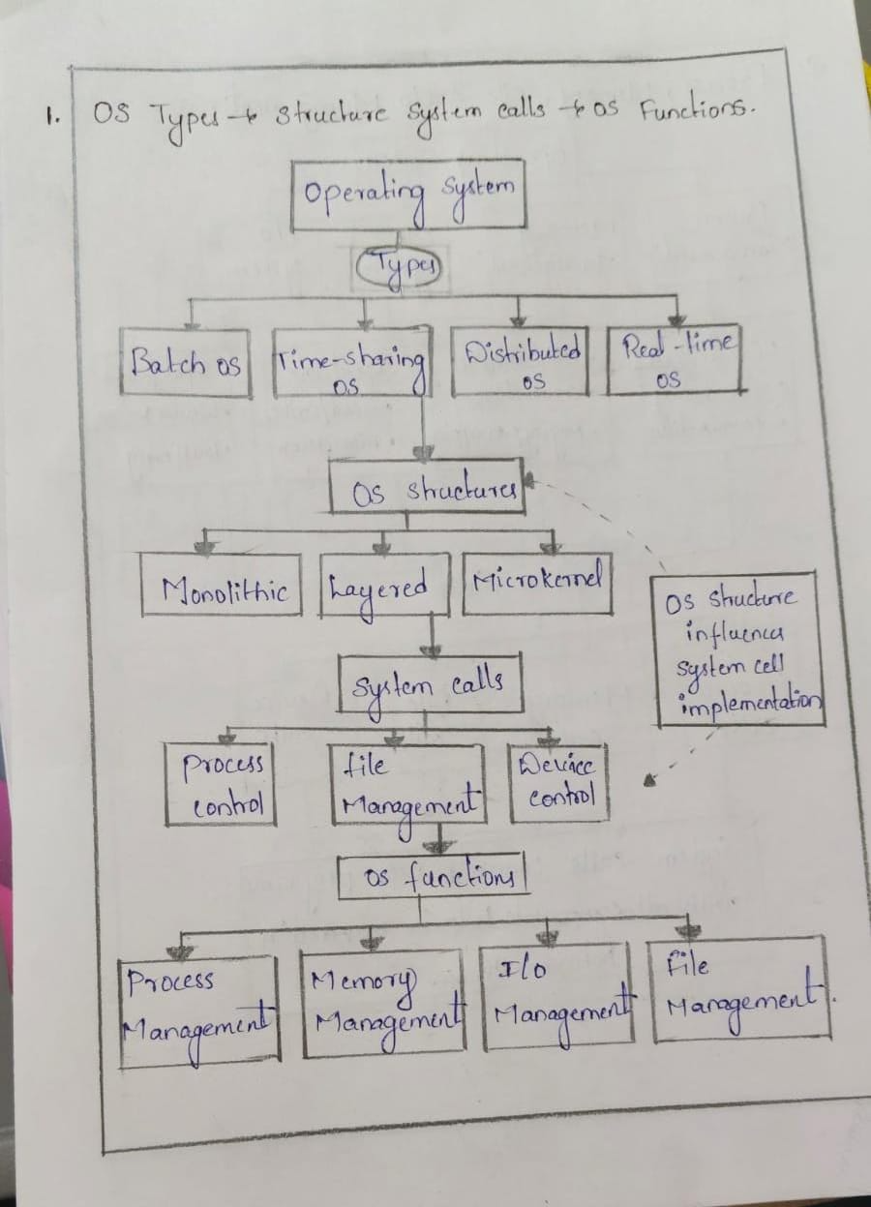
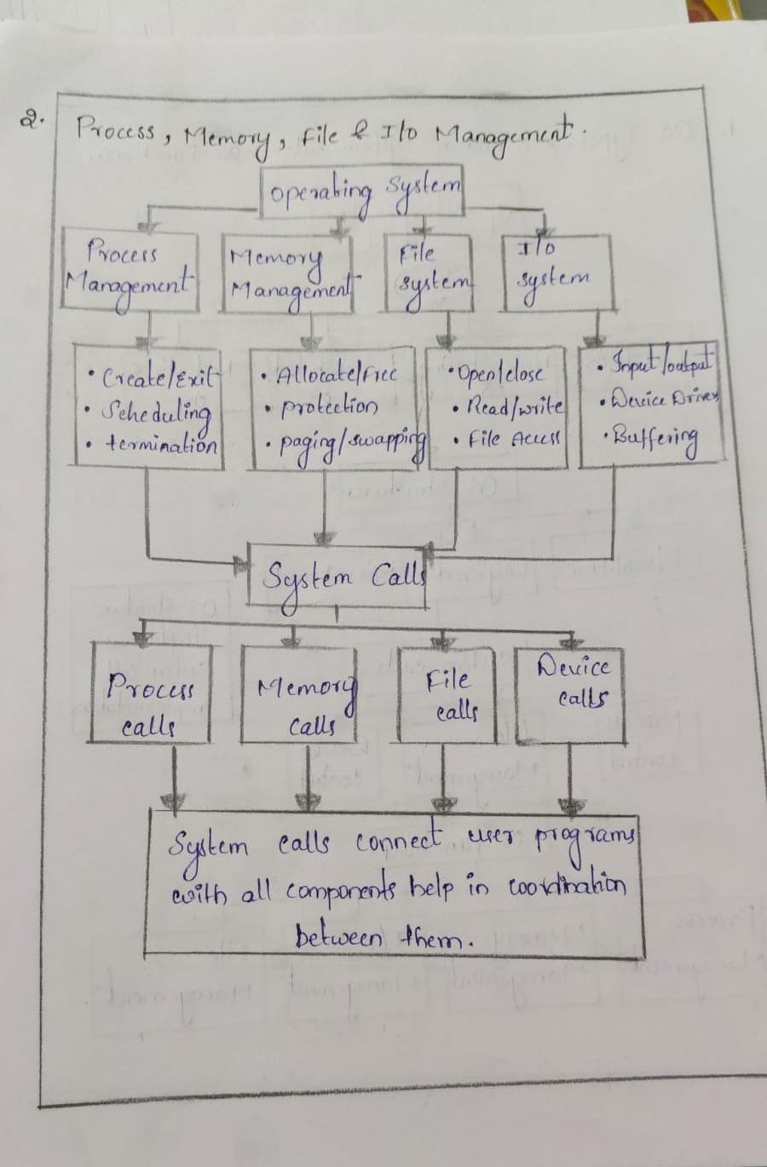
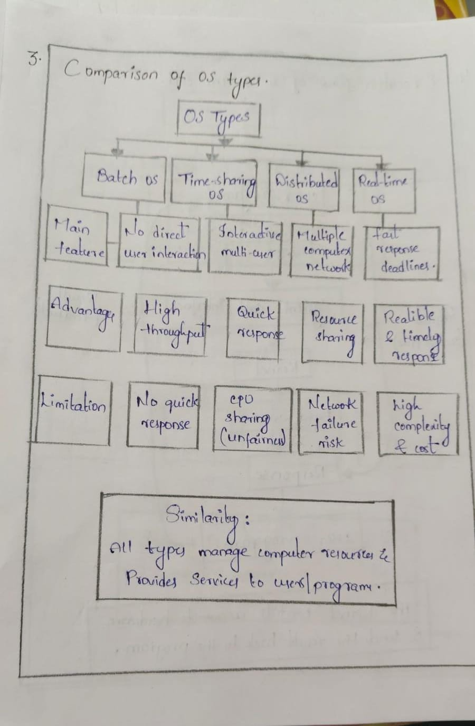
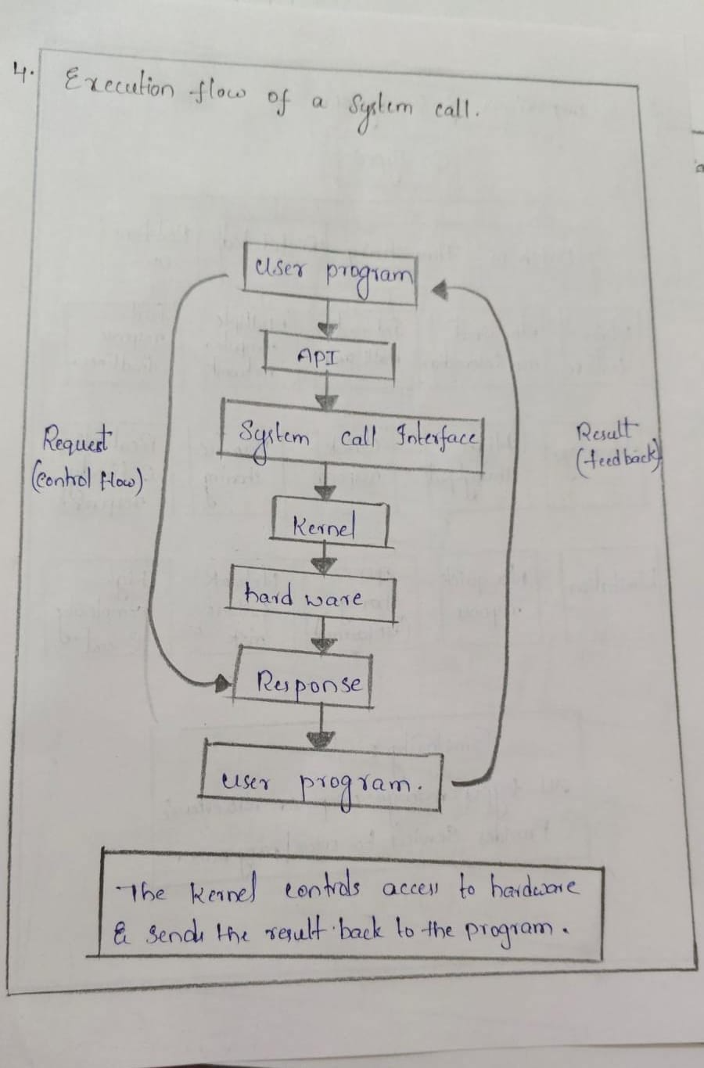
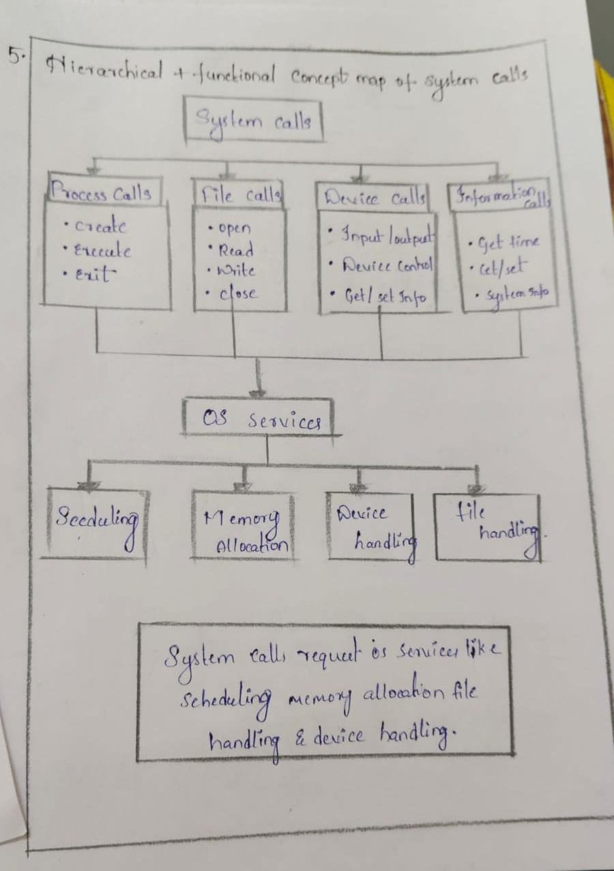

(BL3) RUBRICS FOR CALCULATION
Concept Mapping
Criteria | Weightag e | Level 4 (Exemplary) | Level 3 (Proficient) | Level 2 (Developing) | Level 1 (Beginning)
Concept  Identification | 25% | Identifies all key concepts from literature  accurately and  comprehensivel  y | Identifies most key concepts  with minor omissions | Identifies limited  concepts; some are  irrelevant or missing | Fails to identify  essential concepts
Linkages | 25% | Establishes clear,  meaningful, and accurate  relationships between concepts | Shows correct relationships  with minor gaps | Relationships are weak,  unclear, or  partially incorrect | No meaningful  relationships established
Organization | 20% | Concepts are well-structured hierarchically  with logical flow  and grouping | Mostly organized with minor  structural  issues | Some  organization but lacks clear hierarchy | No logical organization or structure
Integration of Literature | 20% | Integrates multiple studies  effectively to show  connections and  comparisons | Shows some integration of literature | Limited integration; mostly  isolated concepts | No integration of literature evidence
Clarity | 10% | Concept map is clear, neat, visually  structured, and easy to interpret | Generally clear with minor  readability issues | Clarity is reduced;  difficult to  interpret in parts | Poorly presented  and hard to understand

